Module 17 Homework

Mason Deja

8/8/2017

Acid Rain in Shenandoah National Park

1. α=0.01
2. Ho: µ=5.6 vs HA µ <5.6. Where µ is mean ph in Shenandoah National Park.
3. 1-sample t-Test is required (i) quantitative variable (pH) was measured, (ii) individuals for one population (pH levels for Shenandoah National Park, (iii) σ is unknown.
4. The data appears to be part of an observational study with no implied randomization.
5. 90≥40 and the sample distribution is slightly right skewed (figure 1).
6. ¯ x=4.58(table 1)
7. T=-33.53 with 89 degrees of freedom(table 1)
8. P- value=2.2.e-15(table 1)
9. Reject Ho because p-value < α.
10. It appears that the pH of all the rain in Shenandoah National Park is less than the pH of 5.6.
11. I am 99% confident that the mean pH of all rain in Shenandoah National Park is between 4.50 and 4.66(table 1)

Figure 1

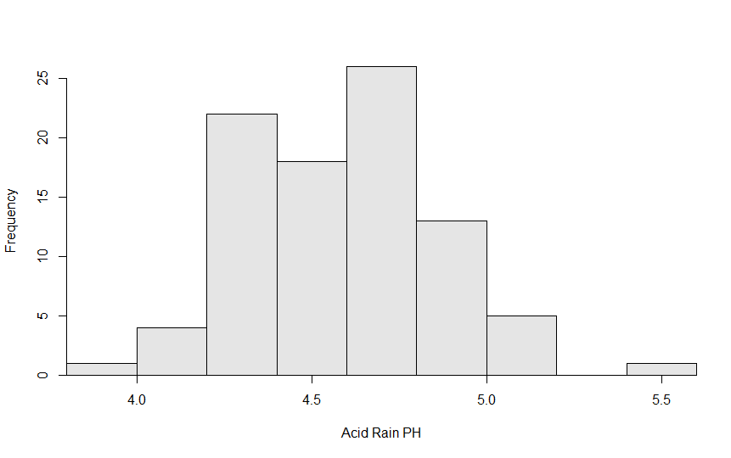

Table 1

t = -33.5303, df = 89, p-value < 2.2e-16

alternative hypothesis: true mean is not equal to 5.6

99 percent confidence interval:

4.497651 4.658127

sample estimates:

mean of x

4.577889

R stuff

library(NCStats)

df<-read.csv("PHlevels.csv")

hist(~pH,data=df,xlab="Acid Rain PH")

t.test(df$pH,mu=5.6,conf.level = 0.99)